Appendix 1
Principles: The approach is grounded in global sensory-motor rehabilitation principles, which draw from the neurodevelopmental concepts pioneered by Bobath. The focus is primarily on the quality of gestures, gait control, inhibition of spasticity, and abnormal movements, rather than the quantity of exercises. The difficulty level of the exercises is increased gradually from one session to another based on the patient's abilities.
Bridging Exercise | While supine with both feet secured, the patient is instructed to lift their pelvis. Verbal or visual cues were provided when necessary. The exercise was performed for ten repetitions, adjusted based on the individual's ability. | 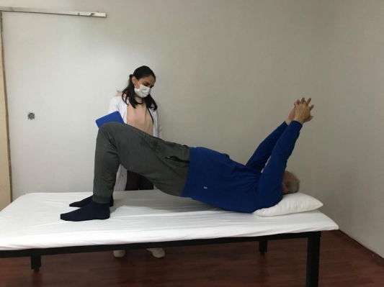
Latissimus Stretch Exercise | While the patient was in a side-lying position, they were instructed to reach upward from under their waist, and they were expected to move their torso away from the hand. Once the patient learned the movement, the instruction given from the waist was no longer provided. | 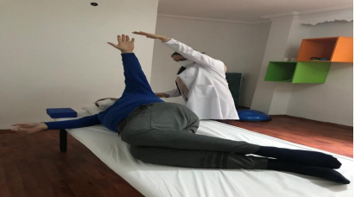
Autoinhibition Exercise | While sitting in a chair, the patient was instructed to lean their torso forward and let their arms hang down, straightening their elbows. Then, they moved and swung their affected arm without changing their position. They gradually straightened their torso to sit upright. In the final stage, with their arms straight, they kept their head lowered and slowly raised to complete the exercise. | 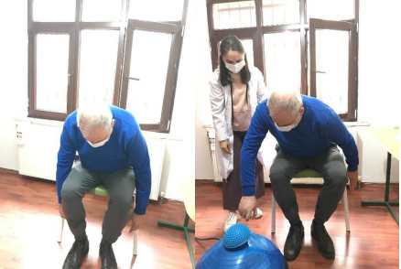
Dorsiflexion Training | While the patient was supine, the front part of the foot and toes were brought into dorsiflexion by holding the dorsal aspect of the foot. While maintaining an eversion position of the foot, the patient was asked to hold their foot up. The exercise was completed for a total of 10 repetitions, based on the ability of the patients. | 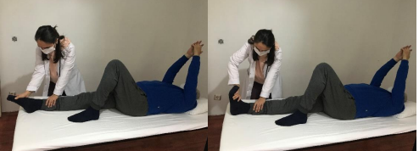
Sitting Balance Training | While the patient's hands were in the Bobath position in a sitting position, small nudges were applied in different directions: right, left, forward, and backward. The patient was asked to resist the movements and maintain the current position. | 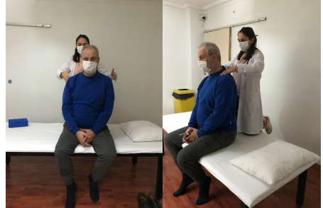
Upper Extremity Weight Shifting Exercise | While the patient was sitting, they were asked to place their hands on the bed with their elbows in extension. Depending on the spasticity and shoulder stability of the patient, support was provided either from the glenohumeral joint or the elbow. | 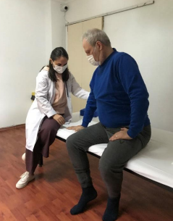
Lower Extremity Weight Shifting Exercise | While the patient was standing, they were asked to be positioned beside the parallel bars for safety. Depending on the patient's condition and the exercise's progress, they were asked to move their unaffected leg to the side or front. This allowed for weight transfer to the hemiplegic lower extremity. | 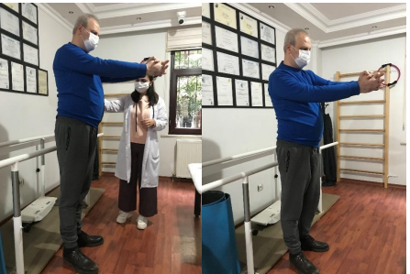
Oblique Abdominal Strengthening Exercise | While the patient was sitting, the therapist stood on the patient's side and presented an object within the patient's reach. The patient was asked to grasp the object. The exercise was repeated on both the affected and unaffected sides. | 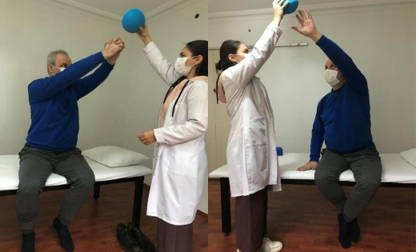
Knee Control Training | While the patient was standing, they were asked to stand with their feet shoulder-width apart. They were guided to shift 30% of their body weight to the affected side and perform flexion-extension movements with both knees. The physiotherapist prevented any unwanted situations that may occur in the knee. The exercise was completed for a total of 10 repetitions. | 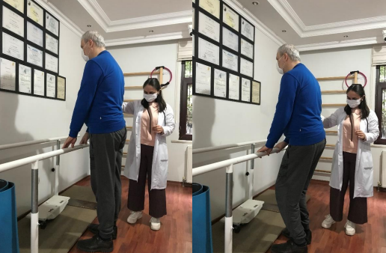
Walking Training | After explaining the standard walking patterns to the patient, walking practice was conducted in front of a mirror. The physiotherapist provided support to patients who needed it. For patients using a cane or tripod, the principles of their use were explained, and they were encouraged to use them properly. | 