Suppl 7. Principal component analysis of the Discovery cohort (n=179) based on traits determined to contribute most significantly to the PPMI Cohort. (A) Scatter plot depicting separation of subjects across the first two principal components. (B) Heatmap of clinical characteristics for each cluster identified. Greater red hue indicates greater prevalence, greater blue hue indicates lower prevalence.
(A)
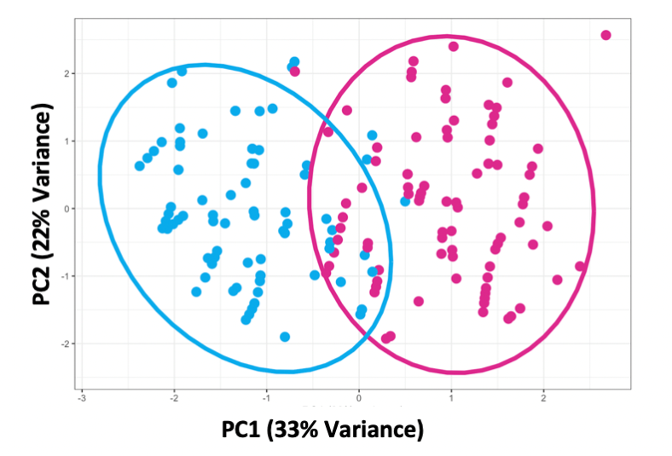

(B)
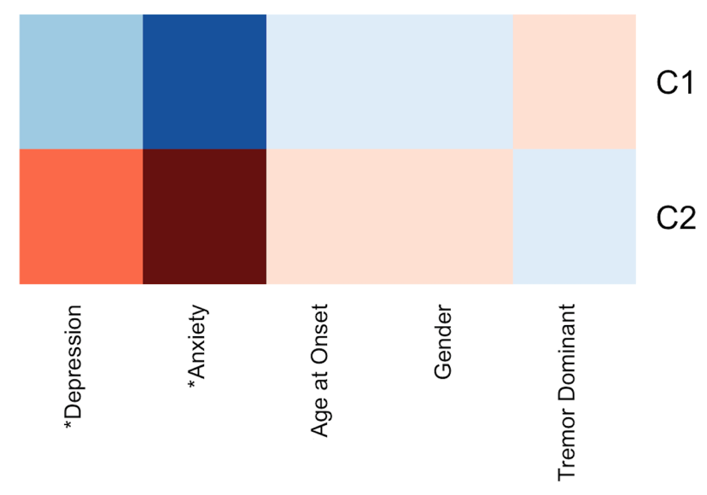
Greater red hue indicates greater prevalence, greater blue hue indicates lower prevalence. Traits with a statistically significant difference between clusters, defined as bonferroni corrected P < 0.05, are indicated with an asterix (*).

